STORAGE AND QUALITY OF AUTUMN PEARS, DEPENDING ON THE DOSE OF POST-HARVEST TREATMENT WITH ETHYLENE INHIBITOR 1-MCP

Oleksandr MELNYK, Olha DROZD

Uman National University of Horticulture,
Instytutska st., Uman, Ukraine

Corresponding author email: olga.drozd@ukr.net

Abstract

The aim of the research was to determine the effect of postharvest SmartFresh treatment of autumn pears (various 1-MCP doses) on the natural weight losses, skin browning, senescent breakdown and ethylene-production, firmness, soluble solids content, titratable acidity and taste during fruit storage. Autumn pears, known in Ukraine as Delbarau RX 12/47 (the local name is also Snizhynka) were cooled to 5 °C and treated with 1-MCP at the dose of 1000 ppb recommended for apples (SmartFreshTM) and experimental doses of 750 and 500 ppb. Fruits were stored at 2±1 °C and relative air humidity 85-90%. With the losses lower than 10%, autumn pears without treatment of 1-MCP can be stored at 2±1 °С for no longer than three months and those treated with an ethylene inhibitor – for no more than four months. А high efficiency of post-harvest treatment of autumn pears with an ethylene inhibitor is achieved at doses of 500, 750 and 1000 ppb 1-MCP. A more harmonious taste of fruits is achieved after the use of smaller doses of 1-MCP.

Key words: 1-MCP, ethylene, pears, physical-chemical parameters, taste.

INTRODUCTION

Market demand for pear fruit is determined by its harmonious taste, aroma and low calorie content. Unlike apple, pears are less resistant to mechanical damage and physiological disorders and they require more careful storage conditions (Konopacka et al., 2014).
Controlled atmosphere and low temperature are the main storage practices for pears. Post-harvest ripening of pears is initiated by ethylene, which has a negative impact on storage duration (Watkins, 2006). An ethylene inhibitor 1-methylcyclopropene (1-MCP) reduces the sensitivity of the fruits to the action of ethylene, thus controlling the rate of maturity and loss of firmness. It also limits skin browning and internal decay and improves product stability during sales (Baritelle et al., 2001; Defilippi et al., 2011).
During storage, the firmness of pears varies considerably, so fruits with a flesh firmness of at least 4.0 kG should be brought to the market and that of 0.8-1.2 kG – for consumption (Ma and Chen, 2003; Blaszczyk, 2011).
The effect of 1-MCP depends on the pomological variety, the degree of harvesting ripeness and the duration of fruit storage (Gamrasni et al., 2010). However, post-harvest treatment of pears with a full dose of 1-MCP, which is recommended for apples, results in the loss of ability to ripen, the fruits remain too firm and do not yellow without acquiring the organoleptic characteristics desired by consumers (Villalobos-Acuna and Mitcham, 2008). Lower doses of 1-MCP delay the onset of climacteric rise and fruit partially restores sensitivity to ethylene (Jeong et al., 2002). Therefore, pear fruits are treated with a half dose of 1-MCP, as compared with apples (Cucchi and Regiroli, 2011).
The aim of this study was to improve the consumer properties of autumn pears by post-harvest treatment with a different dose of 1-MCP, as well as to identify the level and nature of losses, changes of ethylene activity, physical and chemical parameters and tasting evaluation during conventional cold storage.

MATERIALS AND METHODS

The research was conducted in the storage season of 2016/2017 at the Department of fruit growing and viticulture of Uman National University of Horticulture. Common autumn pears, known in Ukraine as Delbarau RX 12/47 (the local name is also Snizhynka), from trees on the rootstock of quince A were selected in the irrigated fruitful orchard with grass in the inter-rows and herbicide strips under trees in Chernivtsi region, Ukraine. Conducting the experiment and processing of the results were performed by standard methods.
The pears were collected in the stage of harvest maturity. Fruits of uniform maturity were selected with a diameter at least 70 mm and they were put into 15 kg boxes with chess stacking. Also, polyethylene nets with fruits were put there to record natural weight losses.
On the day of collection, the fruits were cooled at 5±1 °C and relative air humidity of 85-90%, avoiding the presence of an external source of ethylene – fruits not intended for research. The following day, pears were treated with 1-MCP with experimental doses of 500 (0.034 g/m³), 750 (0.051 g/m³) and a recommended dose for apples – 1000 ppb (0.068 g/m³) of SmartFresh; untreated fruits were the control. For this purpose, boxes with fruits were placed in a gas-tight container of a polyethylene film of 200 microns thick, where a glass of distilled water and a powdered preparation, calculated per volume unit, were placed. The circulation of air in a container was carried out by the fan. After 24-hour exposure, the film container was removed, treated and control fruits were stored at 2±0.5 °C and air humidity of 85-90%.
At harvest, flesh firmness of pears, the content of soluble solids, titratable acidity, iodine/starch test (on the CTIFL scale) and Streif index were determined. The Streif index (SI) was calculated as the ratio of firmness (F, kG) to the soluble solids content (SSC, Brix %) and iodine/starch (S) test (Streif, 1996):
SI = F / (SSC x S)
The estimation of weight loss during storage was periodically done by weighing polyethylene nets with fruit before and after storage. The number of fruits affected by skin browning and senescent breakdown was determined in comparison with the total number of fruits.
The intensity of fruit ethylene production (µl·kg⁻¹·hr⁻¹) was measured with analyzer ICA-56 (International Controlled Atmosphere Ltd) after removing from the cold store and 24-hour warming of fruits, the first measurement was done at 18–20 °C and the others were conducted during shelf-life at the same temperature and relative humidity of 55...60%. Measurements were made on separate batches of fruits. A sample of three or four fruits of a weight approximately 0.5 kg was placed in a 4 liter airtight jar and maintained for 0.5-1 h at 18–20 °C (Melnyk, 2010).
In a 20-fruit sample flesh firmness was determined with penetrometer FT-327 with an 8-mm plunger mounted on a tripod, with two measurements on each pear (skin was removed before the measurement). The content of soluble solids (Brix %) was determined with a refractometer RHB-32ATC and titratable acidity (malic acid, %) was determined by dissolving a known weight of sample in distilled water and titration against 0.01 N NaOH using phenolphthalein as indicator.
Pear organoleptic evaluation was carried out by a permanent panel of 10 people after four months of storage and a week shelf-life at 18-20 °C and relative humidity of 55...60%. Samples of three fruits were blind, marked with numbers. Aroma, hardness, crispiness, juiciness, oiliness, sweet taste, sour taste and overall assessment were evaluated as 10 points – perfect and 1 point – unsatisfactory. Sweet/sour index as the ratio of sweet taste to the sour taste was determined. The effect of the studied factors was evaluated with a multivariate analysis of variance by Statistica 6 with LSD₀₅, P<0.05.

RESULTS AND DISCUSSION

During the harvesting, flesh firmness of pears was 9.0 kG, the content of soluble solids was 11.3%, titratable acidity – 0.29%, iodine/starch test – 6 points and 0.13 – Streif index.

1. Physiological disorders
During the three-month storage, there were no losses from the skin browning in the untreated products, and with 1-MCP treatment, they were at the level of 5.0-8.5% (insignificant difference, Figure 1).
Losses from the scald increased as the duration of storage increased. After four months of storage, only processed fruits were affected, regardless of a doses. Senescent breakdown losses (9.2%) were detected only for untreated fruits after four months of storage, and after treatment with 1-MCP they were not recorded. Similar results were obtained by Chen and Spotts (2005) for d’Anjou pears where, after four months of storage at -1 °C, the fruits treated with an ethylene inhibitor were affected.

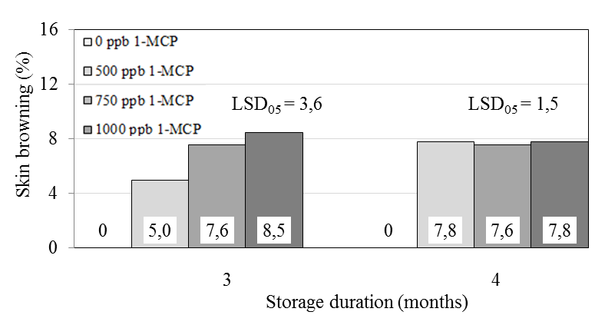
Figure 1. Damage of pears by the skin browning after post-harvest treatment with different doses of 1-MCP during refrigeration storage

2. Natural weight losses
Natural weight losses during storage were steadily increasing (Figure 2). After two months of storage, the rate of fruits treated with a dose of 500 ppb reached 1.5%, which was 1.3-1.4 times lower, as compared with treated ones with doses of 750 and 1000 ppb. After three months of storage, the weight losses of untreated fruits were 1.5-2.0 times higher as compared with the processed ones.

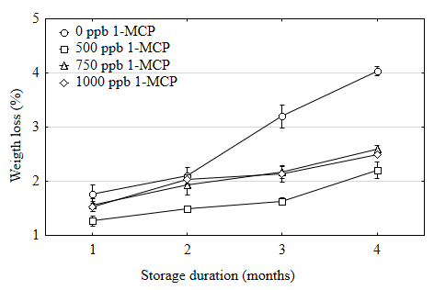
Figure 2. Change of natural weight losses of pears treated with different doses of 1-MCP, during storage

After four months, the natural weight losses of untreated fruits were 1.6-1.8 times higher than that of 1-MCP treated, whereas after treatment with a dose of 500 ppb, the indicator was 1.1-1.2 times lower as compared with the 750 and 1000 ppb doses. Similar results were obtained by Mahajan et al. (2010) during storage of pears cv. Patharnakh.

3. Ethylene activity
Post-harvest treatment with 1-methylcyclopropene significantly inhibited an ethylene production rate of recently harvested fruits (Figure 3).

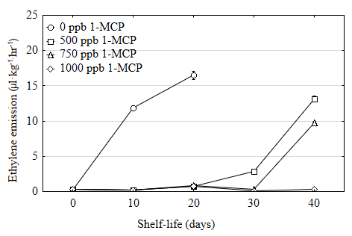
Figure 3. Ethylene production at a temperature of 20 °С by freshly harvested pears, depending on the doses of post-harvest treatment 1-MCP

Ethylene production of untreated fruits steadily increased, and it reached a level of 16.5 µl·kg⁻¹·hr⁻¹ on the 20th day of shelf-life at 20 °C. Regardless of the 1-MCP doses, during first 20 days, the activity of treated fruit ranged within 0.8-0.9 µl·kg⁻¹·hr⁻¹, which was less than the value of untreated pears by 18.3-20.6 times. After 30 days, the ethylene production of fruits treated with a dose of 500 ppb was 2.9 µl·kg⁻¹·hr⁻¹, which was 9.6-29.6 times lower than those with the treatment with doses of 750 and 1000 ppb (lower ethylene production of pear fruit for higher dose of 1-MCP). After 40 days of shelf life at 20 °C, the highest ethylene production of 13,2 µl·kg⁻¹·hr⁻¹ was reached by 500 ppb treated fruits, it was 1.3 times lower for 750 ppb and 44 times lower for 1000 ppb dose.
Untreated 1-MCP fruits also exhibited the highest ethylene production during four months of storage (Figure 4). After three months of common cold storage, untreated fruits have the highest level of 39.0 µl·kg⁻¹·hr⁻¹, it is 13 times lower for 500 ppb dose treatment and at 0,1-0,5 µl·kg⁻¹·hr⁻¹ for fruits treated with doses of 750 and 1000 ppb. After four months of storage, the ethylene production of untreated fruits was 4.8 times higher, as compared with fruits treated with a dose of 500 ppb, and the pear rate treated with doses of 750 and 1000 ppb did not exceed the level of 0,6-0,9 µl·kg⁻¹·hr⁻¹.
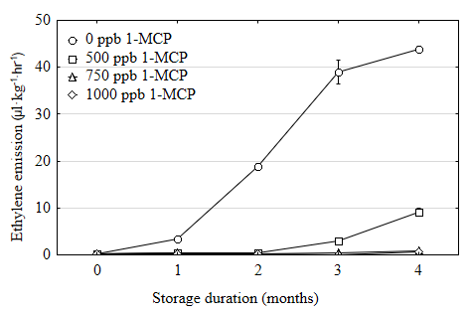
Figure 4. Ethylene production at a temperature of 20 °С by pears during the four-month cold storage, depending on the doses of post-harvest treatment with 1-MCP

A similar pattern was found by Folchi et al. (2014) during storage of pears cv. Abate Fetel.

4. Flesh firmness
Flesh firmness of non-treated fruits was actively reduced, especially in the first three months of storage (Figure 5). The index level of the untreated fruits, which was necessary for shipment to the market, was kept not less than 4.0 kG only during the first three months.

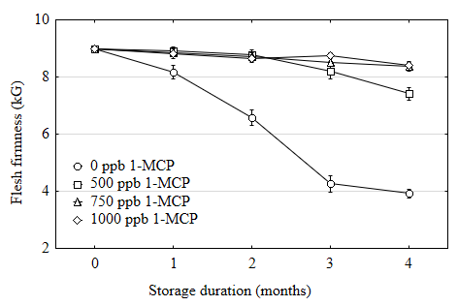
Figure 5. Change in the flesh firmness of pears treated with different doses of 1-MCP, during cold storage

Therefore, without post-harvest treatment with 1-MCP, autumn pears are suitable for sale only during the first three months storage at 2±1 °С, whereas post-harvest treatment provided a 1.9-2.0 times higher level of the indicator, regardless of the dose 1-MCP.
After four months of cold storage, the firmness of the treated fruits was 1.9-2.2 times higher than the untreated ones. After treatment with a dose of 500 ppb the firmness decreased faster and reached 1.1 times lower level than the results of the application of doses 750 and 1000 ppb. Similar results were obtained by Сalvo et al. (2004) during storage of pears cv. Red Clapps.

5. Soluble solids content and titratable acidity
In the initial period of storage, the content of soluble solids of all investigated variants increased to a certain extent, substantially decreasing later (Figure 6).

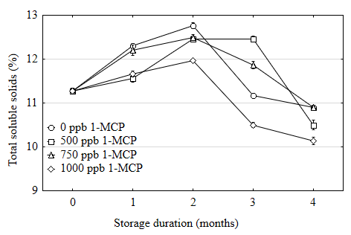
Figure 6. Change in the content of soluble solids in pears treated with different doses of 1-MCP, during storage

During the first two months (three were treated with a dose of 500 ppb), the level of soluble solids increased, decreasing significantly later on. After four months, the highest content of soluble solids was found in untreated fruits and those treated with a 750 ppb dose, it was 0.4% lower at 500 ppb and 0.7% lower at 1000 ppb.
During two months of storage, the content of total soluble solids increased to a certain extent (three months for 500 ppb treatment), decreasing significantly after that. After four months, the higher soluble solids content is found in untreated fruits and fruits treated with a 750 ppb dose, it is 0.4% lower for a 500 ppb dose and it is 0.7% lower for a 1000 ppb treatment.
The content of titratable acidity decreased steadily during pear storage of all the studied variants (Figure 7). After the first 30 days of storage, a significant effect of post-harvest treatment on the change in the content of titratable acidity for pears from all tested doses of 1-MCP was observed. After four months of storage, the acid content of pears treated with 1-MCP was 1.2-1.4 times higher, as compared with untreated fruits.
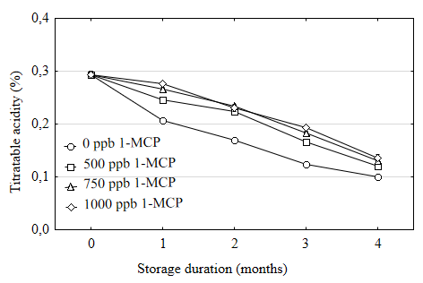
Figure 7. Change in the titratable acidity content in pears treated with different doses of 1-MCP, during storage

At a higher dose of 1-MCP, the content of titratable acidity was also slightly higher. A similar pattern was found by Kurubas et al. (2018) during storage of pears cv Ankara under the treatment with 250 and 500 ppb 1-MCP.
After four months, the content of titratable acidity in the treated pears is higher by 1.2-1.4 times, as compared with non-treated fruits. At higher doses of 1-MCP, the content of titratable acidity is slightly higher.

6. Tasting score
During storage, the ripening of pears treated with 1-MCP is significantly slower (Table).

Table. Organoleptic evaluation of pears with post-harvest treatment at different doses of 1-MCP, after four months of storage and a week shelf life at 20 °С (crop 2016)
Dose of  SmartFresh, ppb | Aroma | Hardness | Crispness | Juiciness | Oiliness | Sweet taste | Sour taste | Sweet/sour index | Overall score
90 days storage + 7 days shelf-life
0 | 8,9 | 2,9 | 2,6 | 9,1 | 6,5 | 5,9 | 3,5 | 2,8 | 7,1
500 | 4,3 | 7,4 | 7,3 | 5,9 | 2,5 | 3,8 | 3,6 | 1,4 | 5,0
750 | 3,2 | 7,4 | 7,8 | 6,0 | 2,3 | 3,9 | 3,4 | 1,5 | 5,4
1000 | 2,6 | 8,3 | 8,3 | 5,1 | 1,9 | 2,7 | 2,8 | 1,2 | 3,8
LSD₀₅* | 0,8 | 1,1 | 1,1 | 1,0 | 1,0 | 0,9 | NS | 1,1 | 0,8
120 days storage + 7 days shelf-life
500 | 6,0 | 3,5 | 3,5 | 8,2 | 8,0 | 5,7 | 4,5 | 1,9 | 7,8
750 | 2,8 | 7,5 | 7,3 | 5,3 | 3,2 | 3,7 | 4,8 | 1,2 | 5,5
1000 | 2,7 | 7,8 | 7,7 | 4,5 | 2,5 | 3,8 | 4,0 | 1,1 | 4,8
LSD₀₅* | 0,6 | 1,8 | 1,2 | 1,8 | 1,8 | 1,3 | NS | NS | 1,1
*NS – not significantly

After three months, the aroma estimate of treated fruits was 2.1-3.4 times lower than untreated ones; however, for a dose of 500 ppb, this estimate was 1.3-1.6 times higher than those for 750 and 1000 ppb.
After three months, the untreated fruits have a higher juiciness – by 3.1-4.0 times, oiliness – by 4.0-4.6 times, sweetness – by 1.5-2.2 times, sweet/sour index – by 1.9-1.3 times and total tasting score was higher by 1.9-1.3 times, as compared with treated fruits.
Regardless of the dose, the treated pears were 2.5-2.8 times hardness and 2.8-3.1 times crispness as compared with the untreated fruits. The juiciness and oiliness of the untreated fruits were 3.1-4.0 and 4.0-4.6 points higher, respectively, as compared with the treated fruits. Untreated pears (5.9 points) were the sweetest, and the index of fruits with 1-MCP treatment was 1.5-2.2 times lower.
No significant effect of treatment with 1-MCP on the degree of sour taste was recorded.
The sweet/sour index of the untreated fruits was 1.5-2.2 times higher as compared with the 1-MCP treated ones. Due to higher indicators of aroma, juiciness, oiliness and sweetness, the untreated fruits received 1.3-1.9 times higher total score than the treated ones, and for the 500 and 750 ppb dose treatments, the scores were 1.3-1.4 times higher than at 1000 ppb.
As compared with the treatment with doses of 750 and 1000 ppb, after four months of storage, the fruits treated with the dose of 500 ppb had higher flavor – by 2.1-2.2 times, lower hardness – by 2.2 times and lower crispness – by 2.1-2.2 times. These fruits had 1.5-1.8 times higher juiciness, 2.5-3.2 higher oiliness and 1.5 times higher sweetness. There was no significant difference between the doses of 1-MCP in terms of sour taste and sweet/sour index. Due to higher other indicators, fruits treated with a dose of 500 ppb received a 1.4-1.6 times higher overall score as compared with the treatment with doses of 750 and 1000 ppb.

CONCLUSIONS

Post-harvest SmartFresh treatment has a significant effect on the storage results of autumn pears, known in Ukraine as Delbarau RX 12/47 (the local name is also Snizhynka), in particular on the natural weight losses, skin browning, senescent breakdown and ethylene-production, firmness, soluble solids content, titratable acidity and taste during fruit storage.
With the losses lower than 10%, autumn pears without treatment of 1-MCP can be stored at 2±1 °С and relative air humidity 85-90% for no longer than three months and those treated with an ethylene inhibitor – for no more than four months. For this purpose, after harvesting, the fruits must be immediately cooled to 5 °C and treated with 1-MCP.
The sale-permissible flesh firmness of the untreated fruit at a level of 4.0 kG is formed when pears are stored at 2±1 °С for not longer than three months, and at this time, post-harvest treatment results in a 1.9-2.0 times higher level of the index, regardless of the 1-MCP dose.
A high efficiency of post-harvest treatment of autumn pears with an ethylene inhibitor is ensured in a wide range of 1-MCP doses – 500-1000 ppb. At lower doses, a more harmonious taste of pears is achieved without reducing storage ability.

ACKNOWLEDGEMENTS

The authors express their gratitude to ‘AgroFresh’ for providing SmartFreshTM preparation to carry out trials.

REFERENCES

Baritelle, A.L., Hyde, G.M., Fellman, J.K., Varith, J. (2001). Using 1-MCP to inhibit the influence of ripening on impact properties of pear and apple tissue. Postharvest Biology and Technology, vol. 23 (2), 153–160. DOI: 10.1016/S0925-5214(01)00107-7.
Blaszczyk, J. (2011). Przechowywanie gruszek. Sad Nowoczesny, vol. 11, 26–29.
Calvo, G. Sozzi, G.O. (2004). Improvement of postharvest storage quality of ‘Red Clapp’s’ pears by treatment with 1-methylcyclopropene at low temperature. Journal of Horticultural Science and Biotechnology, vol. 79(6), 930–934. DOI: 10.1080/14620316.2004.11511868.
Cucchi, A., Regiroli, G. (2011). Temperature and ethylene: two useful tools to be used in combination with SmartFreshSM (1-MCP) for delivering optimal quality pears. ActaHorticulturae, vol. 909, 679–686. DOI: 10.17660/ActaHortic.2011.909.83.
Chen, P.M., Spotts, R.A. (2005). Changes in ripening behavior of 1-MCP treated ‘d’Anjou’ pears. International Journal of Fruit Science, vol. 5(3), 3–18. DOI: 10.1300/J492v05n03_02.
Defilippi, B.G., Manriquez, D., Robledo, P. (2011). Use of 1-Methylcyclopropene (1-MCP) as a strategy to improve post-harvest life of Abate Fetel pears. Acta Horticulturae, vol. 909(91), 739–744. DOI: 10.17660/ActaHortic.2011.909.91.
Folchi, A., Bertolini, P., Mazzoni, D. (2014). Preventing ripening blockage in 1-MCP treated ‘Abate Fetel’ pears by storage temperature management. ActaHorticulturae, vol. 1079(24), 215–221. DOI: 10.17660/ActaHortic.2015.1079.24.
Gamrasni, D., Ben-Arie, R., Goldway, M. (2010). 1-Methylcyclopropene (1-MCP) application to Spadona pears at different stages of ripening to maximize fruit quality after storage. Postharvest Biology and Technology, vol. 58(2), 104–112. DOI: 10.1016/j.postharvbio.2010.05.007.
Jeong, J., Huber, D.J., Sargent, S.A. (2002). Influence of 1-methylcyclopropene (1-MCP) on ripening and cell-wall matrix polysaccharides of avocado (Persea americana) fruit. Postharvest Biology and Technology, vol. 25(3), 241–256. DOI: 10.1016/S0925-5214(01)00184-3.
Konopacka, D., Rutkowski, K.P., Kruczynska, D.E., Skorupinska, A., Plocharski, W. (2014). Quality potential of some new pear cultivars – how to obtain fruit of the best sensory characteristics? Journal of Horticultural Research, vol. 22(2), 71–84. DOI: 10.2478/johr-2014-0024.
Kurubas, M.S., Erkan, M. (2018). Impacts of 1-methylcyclopropene (1-MCP) on postharvest quality of ‘Ankara’ pears during long-term storage. Turkish Journal of Agriculture and forestry, vol. 42, 88-96. DOI:10.3906/tar-1706-72.
Ma, S.S., Chen, P.M. (2003). Storage disorder and ripening behaviour of ‘Doyenne du Comice’ pears in relation to storage conditions. Postharvest Biology and Technology, vol. 28(2), 281-294. DOI: 10.1016/S0925-5214(02)00179-5.
Mahajan, B.V.C., Singh, K. Dhillon, W.S. (2010). Effect of 1-methylcyclopropene (1-MCP) on storage
life and quality of pear fruits. Journal Food Science Technology, vol. 47(3), 351–354. DOI: 10.1007/s13197-010-0058-5.
Melnyk, O.V. (2010). Zbyralna styglіst yabluk: metod іndukovanogo etylenu. Novyny sadіvnyctva, No 3, 36–37.
Streif, J. (1996). Optimum harvest date fot different apple cultivar in the “Bodensee” area. In A. De Jager, D. Johnson, & E. Hohn (Eds.). Determination and prediction of optimum harvest date of apples and pears. COST 94. The postharvest treatment of fruit and vegetables (pp. 15-20). Luxembourg: European Commission.
Villalobos-Acuna, M., Mitcham, E.J. (2008). Ripening of European pears: the chilling dilemma. Postharvest Biology and Technology, vol. 49(2), 187-200. DOI: 10.1016/j.postharvbio.2008.03.003.
Watkins, C.B. (2006). The use of 1-Methylcyclopropene (1-MCP) on fruits and vegetables. Biotechnology Advances, vol. 24(4), 384–409.

